DEVI AHILYA VISHWAVIDYALAYA, INDORE

SCHOOL OF STATISTICS



SESSION 2022-23

A dissertation for partial fulfilment of the Degree of Masters of Science in Statistics on

**“Progress of Information and Communication Technology using Factor Analysis”**

**GUIDED BY- SUBMITTED BY-**

Dr. Rashmi Awad Isha Agrawal

Assistance Proffessor M.Sc. III SEM

School of Statistics DAVV, Indore

DEVI AHILYA VISHWAVIDYALAYA, INDORE

SCHOOL OF STATISTICS

DECLARATION

Project title: Progress of Information and Communication Technology

I Isha Agrawal, certify that this project is my own work, based on my personal study and/or research and that I have acknowledged all material and sources used in its preparation, whether they be books, articles, reports, lecture notes, and any other kind of document, electronic or personal communication. I also certify that this project has not previously been submitted for assessment in any academic capacity, and that I have not copied in part or whole or otherwise plagiarised the work of other persons. I confirm that I have identified and declared all possible conflicts that I may have.

**Date: Signature:**

**_________ ___________**

DEVI AHILYA VISHWAVIDYALAYA, INDORE

SCHOOL OF STATISTICS

FORWORDED

I am pleased to forward the dissertation work of Miss Isha Agrawal on **Progress of Information and Communication Technology** Using **Factor Analysis** Completed under the supervision of Dr. Rashmi Awad, for acceptance as a prerequisite to the degree of Masters of Science, in Statistics

**Date: Dr. V.B. Gupta**

**Head of Department School of Statistics**

**DAVV, Indore (MP)**

DEVI AHILYA VISHWAVIDYALAYA, INDORE

SCHOOL OF STATISTICS

**CERTIFICATE**

This is to certify that dissertation work of Miss

Isha Agrawal entitled **“Progress of Information and Communication Technology** Using **Factor Analysis”** is here by approved as a credible work carried out in partial fulfilment of the degree of Master of Science in Statistics, is a record of work carried out by her under my supervision and guidance. The dissertation well up to standard both in respect of content and its literary presentation for being referred to the examiner.

**Date: Dr. Rashmi Awad**

**Assistant Professor**

**School of Statistics**

**DAVV, Indore**

**ACKNOWLEDMENT**

I feel great pleasure and sense of obligation on completion of my project. I am greatly appreciative to several people who have made this project possible.

First and foremost, I owe this moment of satisfaction, with a deep sense of gratitude to **Dr. Rashmi Awad**, Assistant Professor, School of Statistics, DAVV, Indore, my project guide. She was involved right from the inception of ideas to the finalization of the work or extending her valuable time, guidance, expertise criticism and encouragement for the completion of this work. I am thankful to her for her kind blessings and valuable suggestions.

I would like to express my sincere thanks to all non-teaching staff of school of statistics for their support and advice throughout my project work.

It’s my privilege to say thanks to my family for supporting me each and every moment during the working, without their blessings nothing is possible to achieve for me.

Last but not least I am thankful to all my super seniors, seniors and friends, for their innovative help at-right time to complete my project successively.

**Date: Isha Agrawal**

**ABSTRACT**

This project aims to investigate the impact of Information and Communication Technology (ICT) on organizational efficiency and effectiveness across diverse industries. The rapid evolution of ICT has transformed the way businesses operate, communicate, and deliver services. This research project seeks to provide a comprehensive analysis of the multifaceted role of ICT in enhancing organizational processes.

The study will adopt a mixed-methods approach, combining quantitative data analysis and qualitative insights gathered through surveys, interviews, and case studies. Key objectives include assessing the level of ICT adoption, identifying critical factors influencing successful implementation, and evaluating the correlation between ICT integration and key performance indicators.

**CONTENTS**

* Objective
* Introduction of Information and Communication Technology
* History of ICT
* Example of ICT
* Advantages of ICT
* Introduction of Methodology to be

Used-

* Test of Assosiati0
* Factor Analysis
* Reliability
* Data Analysis and result-
* Description of data & define
* Origin of data
* Questioner
* Descriptive Statistics
* Variables to be used
* Assigning of Variable
* Decoding of variable
* Descriptive Statistics
* Test of Assosiati0 using SPSS
* Factor Analysis using SPSS
* Reliability using SPSS
* Conclusion
* limitation
* Reference

**OBJECTIVE**

This project aims on evaluating the penetration and usage of ICT in College Student. Assess the correlation between ICT adoption and Identify challenges and opportunities associated with ICT implementation.

**INTRODUCTION**

**INFORMATION AND COMMUNICATION TECHNOLOGY**



In the 21st century, Information and Communication Technology (ICT) has evolved into a pervasive force that underpins nearly every aspect of modern life. ICT encompasses a diverse set of technologies and tools that facilitate the acquisition, storage, processing, and dissemination of information. From the personal devices we carry in our pockets to the intricate systems powering global networks, ICT plays a pivotal role in shaping the way individuals, businesses, and societies connect, communicate, and operate.

The foundation of ICT is laid upon a dynamic interplay of hardware, software, networks, and data. The advent of powerful computing devices, coupled with robust software applications, has catalysed a technological revolution, enabling capabilities that were once unimaginable. The seamless exchange of information across the globe, facilitated by intricate communication networks, has transformed the world into an interconnected and interdependent digital ecosystem.

At its core, ICT serves as an enabler of progress and innovation. In the realm of business, organizations leverage ICT to enhance operational efficiency, optimize processes, and gain competitive advantages. The transformative potential of ICT is exemplified by technologies such as cloud computing, artificial intelligence, the Internet of Things (IoT), and big data analytics, which are redefining the way industries operate and create value.

On a societal level, ICT bridges geographical divides, democratizes access to information, and empowers individuals with unprecedented tools for communication, collaboration, and learning. Education, healthcare, governance, and entertainment have all been profoundly influenced by the integration of ICT, fostering new possibilities and avenues for human development.

As we navigate the complexities of a digital age, the study of ICT becomes not only a technological imperative but a key to unlocking opportunities and mitigating challenges. The subsequent sections of this project will delve into the methodology, data analysis, findings, and recommendations, providing a holistic understanding of the role of ICT in driving innovation and efficiency in our interconnected world.

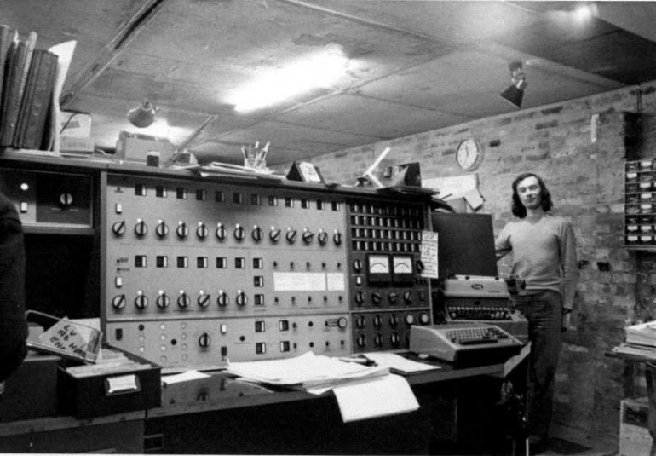

A BRIEF HISTORY OF ICT

The [telegraph](http://www.thecanadianencyclopedia.ca/en/article/telegraph/) (1837) and [telephone](http://www.thecanadianencyclopedia.ca/en/article/telephones/) (1876) permitted communication by wire over long distances almost instantaneously, a vast improvement over the earlier methods of rail, ship and pony express. Communication by wireless telegraph (1895), shortwave radio (1926) and then more reliable high-frequency microwave radio (1946) overcame the physical constraint of connecting every point by wire or cable. Microwave provided larger-capacity communication channels for transmitting television signals and set the stage for the development of satellites and space communication (1957). In the 1970s, mobile communication handsets were developed, as was the basic technology foundation for the Internet and the World Wide Web. Both mobile and Internet communication have grown rapidly since their introduction in the 1980s to the point where mobile access to the Internet (e.g., smartphones) is the dominant and fastest growing form of communication.

The primary thrust of information and communications technology (ICT) development in the 21st century is to expand both the capabilities and the capacity of the equipment and facilities used to communicate over telecommunication networks. Through the 1990s and 2000s, the term *technological convergence* became the catchphrase to describe the way new ICT are being used to bring together what were previously separate communication media — like voice telephone, radio, TV, newspapers and computer data — into one medium, the Internet, provided over enhanced, high-capacity broadband telecommunication networks.

As ICT have continued to improve and the Internet has expanded to near universal coverage in most developed countries, software-based network applications are being developed and applied far beyond the information and communication industries: in the banking, retail and services sector; in industrial production, agriculture, education and medical services; and in government services ranging from issuing licenses to taxation. Increased capabilities for gathering enormous volumes of detailed information (meta data) and the establishment of networks of communicating devices (e.g., Internet) have provided new opportunities for beneficial applications in fields such as science, health and environmental monitoring, but also facilitated serious erosions of privacy by enabling spying on individuals and organisations by governments, corporations and sophisticated hackers.

THE INTERNET

The **Internet** was invented as a result of researches conducted in the early 1960s by visionary people like J.C.R. Licklider of MIT. The latter saw the added value of allowing computers to share information on research and development in scientific and military fields. That’s why, he proposed a global network of computers in 1962, and moved over to the Defense Advanced Research Projects Agency (DARPA) in late 1962 to head the work to develop it.

### THE WEB

While many people use the terms **Internet** and the **Web** interchangeably, they are in fact not synonymous. The Internet is a huge network that connects millions of computers together worldwide. Computers in this network can communicate with any other computer as long as they are connected to the Internet. The Web or the World Wide Web (WWW), however, is a way of accessing information over the medium of the Internet. It is an information space or a model that is built on top of the Internet where documents and other web resources are identified by URLs (Uniform Resource Locator), informally termed a web address. This space is interlinked by hypertext links, and can be accessed via the Internet.

The World Wide Web was invented by English scientist Tim Berners-Lee in 1989. He wrote the first web browser in 1990 while employed at CERN in Switzerland.

## ICT FOR EDUCATION

Many educators saw in ICT the potential of raising the quality of teaching and learning. Here is what it can offer to education:

* Universal access to high quality education.
* Teachers’ professional development.
* Efficient education management in terms of governance and administration.
* Promotion of equity in education.

For teachers, ICT offers a mine of content, material, and ideas.

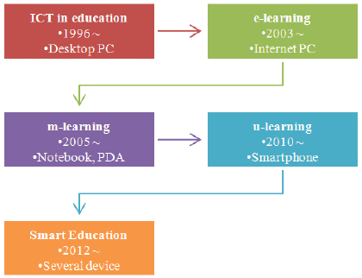

EXAMPLES OF ICT TOOLS

ICT can offer different Web tools:

* websites
* wikis
* blogs
* forums
* applications
* …

And the list is not exhaustive.

ADVANTAGES OF ICT:

* Increasing access through distant learning.
* Enabling a knowledge network for students.
* Training teachers.
* Broadening the availability of quality education materials.
* Enhancing the efficiency and effectiveness of educational administration and policy.
* Social skills.
* Research and development.
* Professional development.
* Policy and strategic planning.

**METHODOLOGY USED**.

CHI SQUARE OF ASSOSIATION

The Chi-Square Test of Independence determines whether there is an association between categorical variables (i.e., whether the variables are independent or related). It is a nonparametric test.

This test is also known as:

* Chi-Square Test of Association.

This test utilizes a contingency table to analyse the data. A contingency table (also known as a *cross-tabulation*, *crosstab*, or *two-way table*) is an arrangement in which data is classified according to two categorical variables. The categories for one variable appear in the rows, and the categories for the other variable appear in columns. Each variable must have two or more categories. Each cell reflects the total count of cases for a specific pair of categories.

Common Uses

assumption of the independence of observations is violated. In this situation, McNamar’s Test is appropriate.

The Chi-Square Test of Independence is commonly used to test the following:

* Statistical independence or association between two categorical variables.

The Chi-Square Test of Independence can only compare categorical variables. It cannot make comparisons between continuous variables or between categorical and continuous variables. Additionally, the Chi-Square Test of Independence only assesses *associations* between categorical variables, and cannot provide any inferences about causation.

If your categorical variables represent "pre-test" and "post-test" observations, then the chi-square test of independence **is not appropriate**. This is because the assumption of the independence of observations is violated. In this situation, McNamar’s Test is appropriate.

## Hypotheses

The null hypothesis (*H*0) and alternative hypothesis (*H*1) of the Chi-Square Test of Independence can be expressed in two different but equivalent ways:

*H*0: "[Variable 1] is independent of [Variable 2]"  
*H*1: "[Variable 1] is not independent of [Variable 2]"

OR

H0: "[Variable 1] is not associated with [Variable 2]"  
*H*1*:*"[Variable 1] is associated with [Variable 2]"

The null hypothesis (*H*0) and alternative hypothesis (*H*1) of the Chi-Square Test of Independence can be expressed in two different but equivalent ways:

*H*0: "[Variable 1] is independent of [Variable 2]"  
*H*1: "[Variable 1] is not independent of [Variable 2]"

OR

H0: "[Variable 1] is not associated with [Variable 2]"  
*H*1*:*"[Variable 1] is associated with [Variable 2]"

## Test Statistic

The test statistic for the Chi-Square Test of Independence is denoted *Χ*2, and is computed as: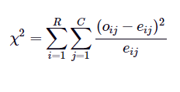

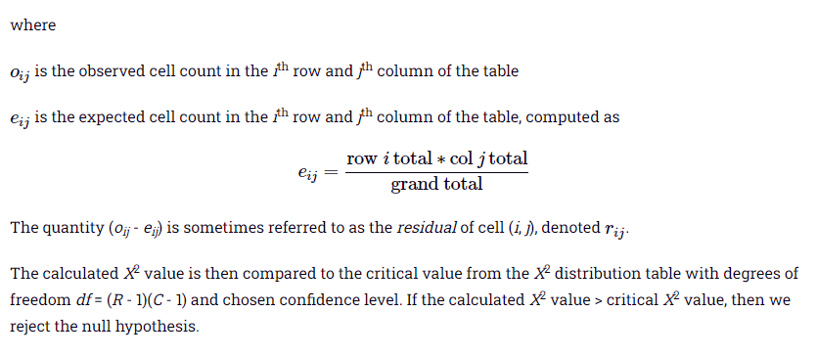

FACTOR ANALYSIS

**What is Factor Analysis?**

It refers to a method that reduces a large variable into a smaller variable factor. Furthermore, this technique takes out maximum ordinary variance from all the [variables](https://www.toppr.com/guides/business-economics-cs/mathematics-of-finance-and-elementary-probability/random-variables/) and put them in common score.

Moreover, it is a part of General Linear Model (GLM) and it believes several theories that contain no multicollinearity, linear relationship, true [correlation](https://www.toppr.com/guides/fundamentals-of-business-mathematics-and-statistics/correlation-and-regression-cma/), and relevant variables into the analysis among factors and variables.

**Types of Factor Analysis**

There are different methods that we use in factor analysis from the data set:

#### **1. Principal component analysis**

It is the most common method which the researchers use. Also, it extracts the maximum variance and put them into the first factor. Subsequently, it removes the variance explained by the first factor and extracts the second factor. Moreover, it goes on until the last factor.

#### **2. Common Factor Analysis**

It’s the second most favoured technique by researchers. Also, it extracts common variance and put them into [factors](https://www.toppr.com/guides/maths/be-my-multiple-ill-be-your-factor/factors-of-a-number/). Furthermore, this technique doesn’t include the variance of all variables and is used in SEM.

#### **3. Image Factoring**

It is on the basis of the correlation matrix and makes use of OLS regression technique in order to predict the factor in image factoring.

#### **4. Maximum likelihood method**

It also works on the correlation matrix but uses a maximum likelihood method to factor.

#### **5. Other methods of factor analysis**

Alfa factoring outweighs least squares. Weight square is another regression-based method that we use for factoring.

**Factor loading-** Basically it the correlation coefficient for the factors and variables. Also, it explains the variable on a particular factor shown by variance.

**Eigenvalues-** Characteristics roots are its other name. Moreover, it explains the variance shown by that particular factor out of the total variance. Furthermore, commonality column helps to know how much variance the first factor explained out of total variance.

**Factor Score-** It’s another name is the component score. Besides, it’s the score of all rows and columns that we can use as an index for all variables and for further analysis. Moreover, we can standardize it by multiplying it with a common term.

**Rotation method-** This method makes it more reliable to understand the output. Also, it affects the eigenvalues method but the eigenvalues method doesn’t affect it. Besides, there are 5 rotation methods: (1) No Rotation Method, (2) Varimax Rotation Method, (3) Quart Imax Rotation Method, (4) Direct Oblimin Rotation Method, and (5) Promax Rotation Method.

**Assumptions of Factor Analysis**

Factor analysis has several assumptions. These include:

1. There are no outliers in the data.
2. The sample size is supposed to be greater than the factor.
3. It is an interdependency method so there should be no perfect multicollinearity between the variables.
4. Factor analysis is a linear function thus it doesn’t require homoscedasticity between variables.
5. It is also based on the linearity assumption. So, we can also use non-linear variables. However, after a transfer, they change into a linear variable.
6. Moreover, it assumes interval data.

**Key Concepts of Factor Analysis**

It includes the following key concept:

Exploratory factor analysis- It assumes that any variable or indicator can be associated with any factor. Moreover, it is the most common method used by researchers. Furthermore, it isn’t based on any prior theory.

Confirmatory Factor Analysis- It is used to determine the factors loading and factors of measured variables, and to confirm what it expects on the basis of pre-established assumption. Besides, it uses two approaches:

**What is Reliability testing?**

Reliability Testing is an important software testing technique that is performed by the team to ensure that the software is performing and functioning consistently in each environmental condition as well as in a specified period. It ensures that product is fault free and is reliable for its intended purpose.

Reliability Testing incorporates the results from both functional and non-functional testing such as Stress testing, Security testing, Functional testing, Production testing and more.

This enables the team to determine various problems in software design and functionality.

**Objectives of Reliability Testing:**

The main objective of Reliability testing is to test the performance of software under a condition. Other objectives are:

* To discover the structure of repetitive breakdowns
* To find the number of failures that occur in a predetermined measure of time
* To locate the mean existence of the software
* To find the primary driver that is the cause of failure

**What are the features of Reliability Testing?**

* One of the features is the ability of the software to work accurately under given condition
* Reliability testing helps identify the issues and faults in a product before it is delivered to the customer
* Reliability testing ensures that it meets the Clients’ as well as Customers’ requirements.
* Reliability testing is performed at various levels of Software development, increasing the reliability and dependability of the product
* It helps uncover the issues in the software design and functionality

CORNBACH’S ALPHA

Cronbach’s alpha is a measure of internal consistency, that is, how closely related a set of items are as a group.    It is considered to be a measure of scale reliability. A “high” value for alpha does not imply that the measure is unidimensional. If, in addition to measuring internal consistency, you wish to provide evidence that the scale in question is unidimensional, additional analyses can be performed. Exploratory factor analysis is one method of checking dimensionality. Technically speaking, Cronbach’s alpha is not a statistical test – it is a coefficient of reliability (or consistency).

Cronbach’s alpha can be written as a function of the number of test items and the average inter-correlation among the items.  Below, for conceptual purposes, we show the formula for the Cronbach’s alpha:

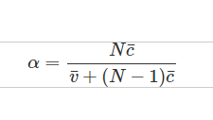

Here N is equal to the number of items, c bar is the average inter-item covariance among the items and v bar equals the average variance.

One can see from this formula that if you increase the number of items, you increase Cronbach’s alpha. Additionally, if the average inter-item correlation is low, alpha will be low.  As the average inter-item correlation increases, Cronbach’s alpha increases as well (holding the number of items constant)

**DATA ANALYSIS AND RESULT**

**Data Collection/Sources of Data:**

Primary data collection is used here. To collect data, we first built-up a

Questionnaire. After the questionnaire is prepared its send to student by means of Google form on social platform. First the questionnaire was pre tested on 30 people and then the data was edited, legibility was checked completeness was checked and the incomplete data was removed, and confusions of students was solved. After the complete editing the questionnaire was send to everyone. And the data was recorded on excel sheet and used for further studies.

Challenges related to data collection:

* Nonresponse or respondents filling in answers at random simply to complete the survey.
* Literacy comprehension barriers.
* Language comprehension barrier.
* Lack of understanding of context.

**GOOGLE FORM LINK:**

[**https://docs.google.com/forms/d/e/1FAIpQLSc3gWAY5ZvVV3OrAU1E70be0YYGg1-mDOEx8dFcb8ymQYD6cw/viewform?usp=sf_link**](https://docs.google.com/forms/d/e/1FAIpQLSc3gWAY5ZvVV3OrAU1E70be0YYGg1-mDOEx8dFcb8ymQYD6cw/viewform?usp=sf_link)

**The question are as follows:**

* General profile of student.
* Gender of student.
* Age group
* Which district do you belong to?
* In which city or district, you have completed or pursuing your graduation?
* Which medium do you belong to?
* Type of your college?
* Do you use ICT for research and project?
* Which Software's you use for your studies and research?
* What percentage do you watch online lectures on YouTube?
* Do you compare same topic or classes you have attended practically with online lectures present in other sites?
* If yes, how much you are satisfied with your classroom lecture you attended practically?
* did you find job opportunities through ICT?
* how much you are satisfied with lectures present in ICT?
* Usage of Internet throughout a day?
* Do you think that using Information Technology (IT/ICT) too much is affecting your health?
* If yes, what damage are you seeing in your body?
* Do you get diverted from your work because of IT/ICT?
* do you feel with family time is reduced because of over usage of IT/ICT?
* Accounts in Social Network
* Major sites Visited by you.
* After using ICT what skills you have developed?
* Do you think using IT/ICT has made a difference in your communication skills?
* How much changes have occurred in your communication since you have been using IT/ICT?

**Descriptive Statistics and charts of data-**

|  |  |  |  |  |  |  |
| --- | --- | --- | --- | --- | --- | --- |
| **Descriptive Statistics** | | | | | | |
|  | N | Range | Minimum | Maximum | Mean | Std. Deviation |
| Do you use ICT for research and project? | 106 | 1 | 0 | 1 | .45 | .500 |
| Usage of Internet throughout a day? | 106 | 2 | 3 | 5 | 4.62 | .624 |
| Do you think using IT/ICT has made a difference in your communication skills? | 106 | 2 | 0 | 2 | 1.04 | .600 |
| Do you think that using Information Technology (IT/ICT) too much is affecting your health? | 106 | 1 | 0 | 1 | .85 | .360 |
| Do you get diverted from your work because of IT/ICT? | 106 | 1 | 0 | 1 | .52 | .502 |
| How much time do you feel with family is reduced because of over usage of IT/ICT? | 106 | 1 | 0 | 1 | .67 | .473 |
| After using ICT what skills you have developed? | 106 | 2 | 1 | 3 | 2.56 | .817 |
| How much changes have occurred in your communication since you have been using IT/ICT? | 106 | 3 | 1 | 4 | 2.47 | .886 |
| What percentage do you watch online lectures on YouTube? | 106 | 3 | 1 | 4 | 2.66 | .904 |
| Do you compare same topic or classes you have attended practically with online lectures present in other sites? | 106 | 1 | 0 | 1 | .87 | .340 |
| If yes, how much you are satisfied with your classroom lecture or boarding methode? | 106 | 2 | 1 | 3 | 1.59 | .673 |
| How much you are satisfied with lectures present in ICT? | 106 | 2 | 1 | 3 | 1.90 | .804 |
| did you find job opportunities through ICT ? | 106 | 1 | 0 | 1 | .52 | .502 |
| Valid N (listwise) | 106 |  |  |  |  |  |

|  |  |  |  |  |  |
| --- | --- | --- | --- | --- | --- |
| **General profile of student.** | | | | | |
|  | | Frequency | Percent | Valid Percent | Cumulative Percent |
| Valid | Arts | 10 | 9.4 | 9.4 | 9.4 |
| Commerce | 21 | 19.8 | 19.8 | 29.2 |
| Computer and mathematical Science | 67 | 63.2 | 63.2 | 92.5 |
| Medical science | 8 | 7.5 | 7.5 | 100.0 |
| Total | 106 | 100.0 | 100.0 |  |

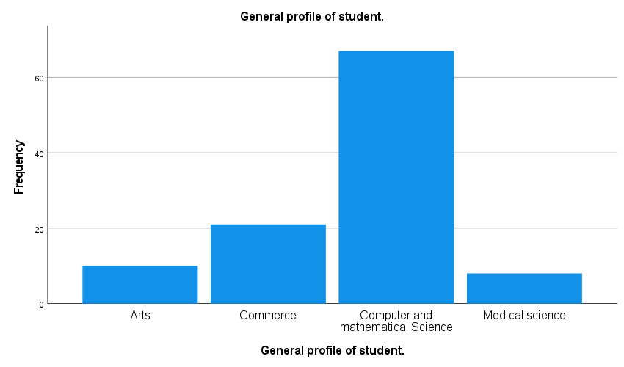

|  |  |  |  |  |  |
| --- | --- | --- | --- | --- | --- |
| **Gender of student.** | | | | | |
|  | | Frequency | Percent | Valid Percent | Cumulative Percent |
| Valid | Female | 52 | 49.1 | 49.1 | 49.1 |
| Male | 54 | 50.9 | 50.9 | 100.0 |
| Total | 106 | 100.0 | 100.0 |  |

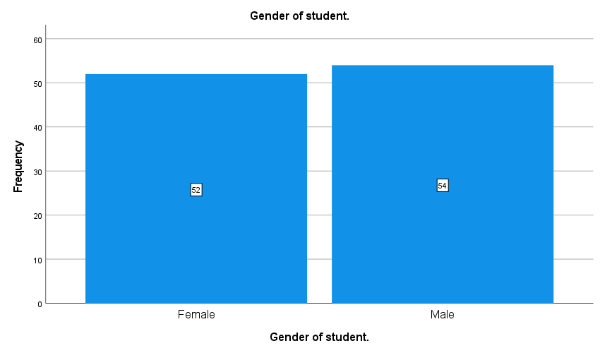

|  |  |  |  |  |  |
| --- | --- | --- | --- | --- | --- |
| **Age group** | | | | | |
|  | | Frequency | Percent | Valid Percent | Cumulative Percent |
| Valid | 18-20 | 16 | 15.1 | 15.1 | 15.1 |
| 20-22 | 50 | 47.2 | 47.2 | 62.3 |
| 22-24 | 38 | 35.8 | 35.8 | 98.1 |
| above 24 | 2 | 1.9 | 1.9 | 100.0 |
| Total | 106 | 100.0 | 100.0 |  |

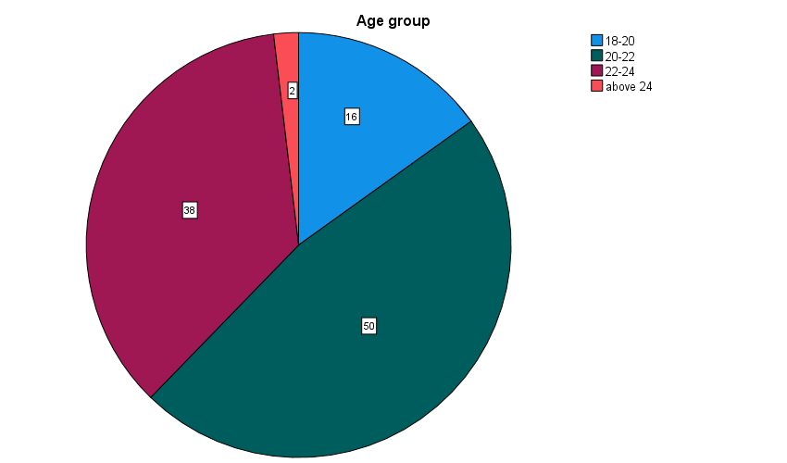

* **Which medium do you belong to?**

|  |  |  |  |  |  |
| --- | --- | --- | --- | --- | --- |
| **Which medium do you belong to?** | | | | | |
|  | | Frequency | Percent | Valid Percent | Cumulative Percent |
| Valid | English | 88 | 83.0 | 83.0 | 83.0 |
| hindi | 18 | 17.0 | 17.0 | 100.0 |
| Total | 106 | 100.0 | 100.0 |  |

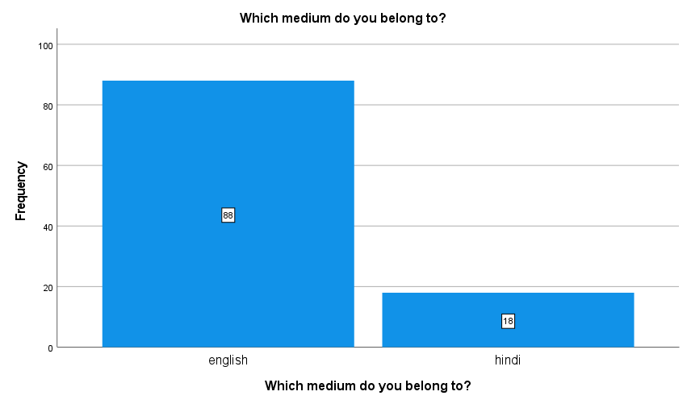

|  |  |  |  |  |  |
| --- | --- | --- | --- | --- | --- |
| **Do you use ICT for research and project?** | | | | | |
|  | | Frequency | Percent | Valid Percent | Cumulative Percent |
| Valid | no | 58 | 54.7 | 54.7 | 54.7 |
| yes | 48 | 45.3 | 45.3 | 100.0 |
| Total | 106 | 100.0 | 100.0 |  |

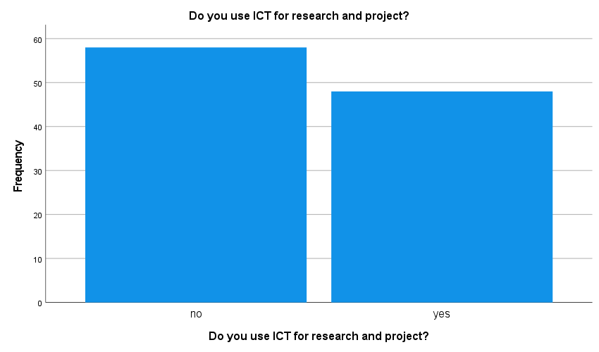

|  |  |  |  |  |  |
| --- | --- | --- | --- | --- | --- |
| **What percentage do you watch online lectures on YouTube?** | | | | | |
|  | | Frequency | Percent | Valid Percent | Cumulative Percent |
| Valid | 0-25% | 13 | 12.3 | 12.3 | 12.3 |
| 26-50% | 28 | 26.4 | 26.4 | 38.7 |
| 51-75% | 47 | 44.3 | 44.3 | 83.0 |
| above 75% | 18 | 17.0 | 17.0 | 100.0 |
| Total | 106 | 100.0 | 100.0 |  |

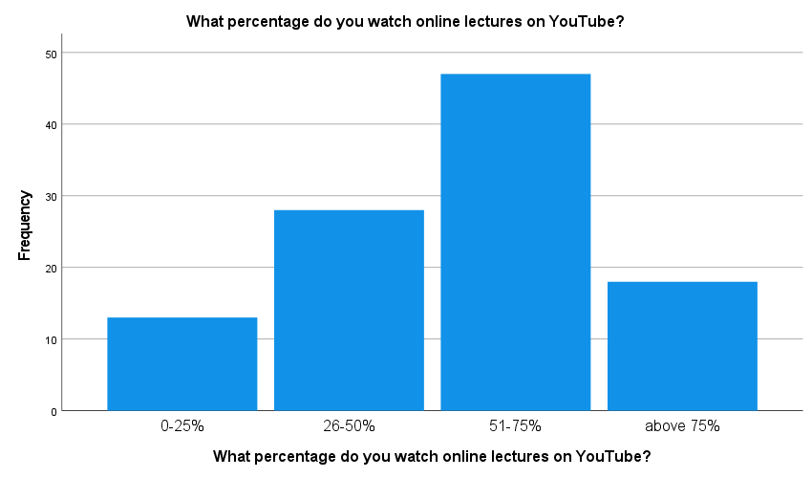

|  |  |  |  |  |  |
| --- | --- | --- | --- | --- | --- |
| **Usage of Internet throughout a day?** | | | | | |
|  | | Frequency | Percent | Valid Percent | Cumulative Percent |
| Valid | 2-3hr | 8 | 7.5 | 7.5 | 7.5 |
| 2-3hr | 24 | 22.6 | 22.6 | 30.2 |
| more than 3 | 74 | 69.8 | 69.8 | 100.0 |
| Total | 106 | 100.0 | 100.0 |  |

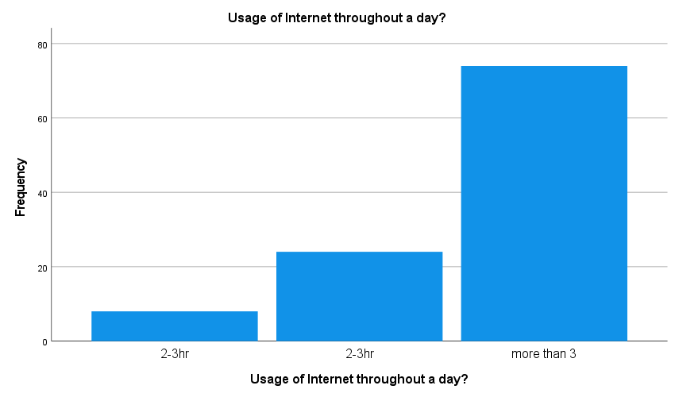

|  |  |  |  |  |  |
| --- | --- | --- | --- | --- | --- |
| * **Do you think that using Information Technology (IT/ICT) too much is affecting your health?** | | | | | |
|  | | Frequency | Percent | Valid Percent | Cumulative Percent |
| Valid | no | 16 | 15.1 | 15.1 | 15.1 |
| yes | 90 | 84.9 | 84.9 | 100.0 |
| Total | 106 | 100.0 | 100.0 |  |

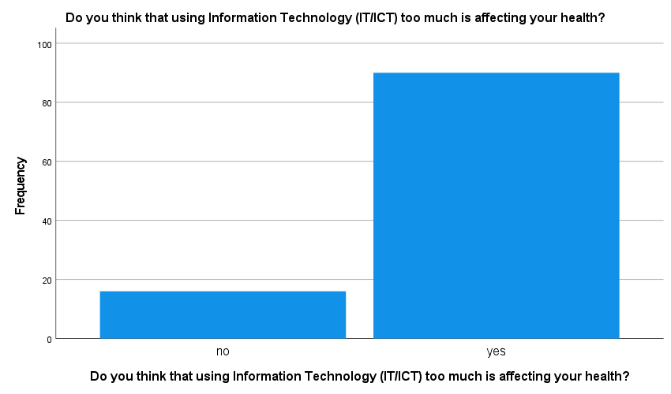

|  |
| --- |
|  |

|  |  |  |  |  |  |
| --- | --- | --- | --- | --- | --- |
| **Do you think using IT/ICT has made a difference in your communication skills?** | | | | | |
|  | | Frequency | Percent | Valid Percent | Cumulative Percent |
| Valid | no | 17 | 16.0 | 16.0 | 16.0 |
| yes | 68 | 64.2 | 64.2 | 80.2 |
| maybe | 21 | 19.8 | 19.8 | 100.0 |
| Total | 106 | 100.0 | 100.0 |  |

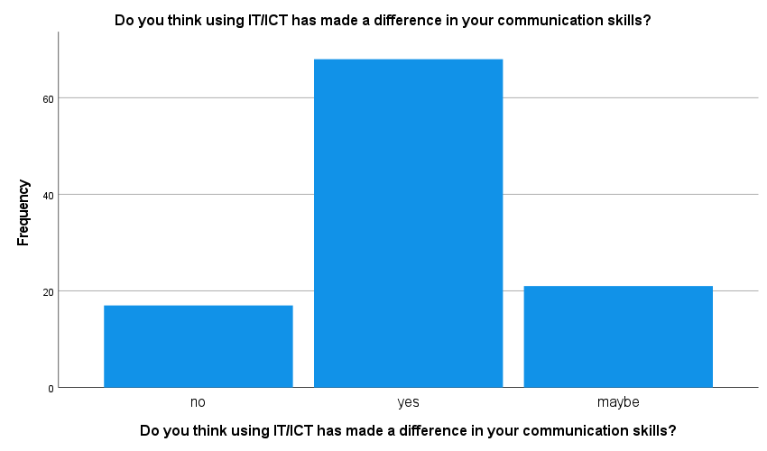

**Variables assigning and decoding-**

**For Factor Analysis-**

**Q1 =** Do you use ICT for research and project?

**1 = “yes”, 0 = “no”**

**Q2 =** Usage of Internet throughout a day?

**1 = “never”, 2 = “0-1hr”, 3 = “1-2hr”, 4 = “2-3hr”, 5 = “more than 3”**

**Q3 =** Do you think using IT/ICT has made a difference in your

communication skills?

**1 =” yes”, 2 = “maybe”, 0=”no”**

**Q4 =** Do you think that using Information Technology (IT/ICT)

too much is affecting your health?

**1 = “yes”, 0 = “no”**

**Q5 =** Do you get diverted from your work because of IT/ICT?

**1 = “yes”, 0 = “no”**

**Q6 =** do you feel time with family is reduced because

of over usage of IT/ICT?

**1 = “yes”, 0 = “no”**

**Q7 =** After using ICT what skills you have developed?

**1 =** “**language”, 2 = “knowledge”, 3 = “both”**

**Q8 =** How much changes have occurred in your communication

since you have been using IT/ICT?

**0-25% = 1, 25-50% = 2, 50-75% = 3, above 75 = 4**

**Q9 =** What percentage do you watch online lectures on YouTube?

**0-25% = 1, 25-50% = 2, 50-75% = 3, above 75 = 4**

**Q10 =** Do you compare same topic or classes you have attended

practically with online lectures present in other sites?

**1 = “yes”, 0 = “no”**

**Q11 =** If yes, how much you are satisfied with your classroom

lecture you attended practically?

**1 = “not satisfied”, 2 = “satisfied”, 3 = “very satisfied”**

**Q12 =** how much you are satisfied with lectures present in ICT?

**1 = “not satisfied”, 2 = “satisfied”, 3 = “very satisfied”**

**Q13 =** did you find job opportunities through ICT?

**1 = “yes”, 0 = “no”**

**For test of association-**

**E1 =** If yes, what damage are you seeing in your body?

**1= “Eye damage”, 0 = “not eye damage”**

**E2 =** Do you get diverted from your work because of IT/ICT?

**1 = “yes”, 0 = “no”**

**E3** = do you feel time with family is reduced because of over usage of IT/ICT?

**1 = “yes”, 0 = “no”**

**E4 =** Accounts in Social Network.

**1 = “Instagram, Facebook, linked In”, 0 = “not”**

**E5 =** Major sites Visited by you.

**1 = “YouTube”, 0 = “not YouTube”**

**CHI SQUARE OF ASSOSIATION**

The Chi-Square Test of Independence determines whether there is an association between categorical variables (i.e., whether the variables are independent or related). It is a nonparametric test.

We have to see association between age group and variable E1, E2, E3, E4, E5

Here we labelled the total score in scale of 1 to 5

1 – excellent

2 – very good

3 – good

4 – bad

5 – very bad

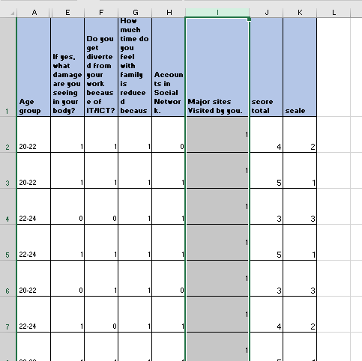

Then we apply the test of association –

*H*0: Age group is independent of variable [E1, E2, E3, E4, E5]  
*H*1: Age group is not independent of variable [E1, E2, E3, E4, E5]

|  |  |  |  |  |  |  |
| --- | --- | --- | --- | --- | --- | --- |
| **Crosstab** | | | | | | |
| Count | | | | | | |
|  | | Age group | | | | Total |
| 18-20 | 20-22 | 22-24 | above 24 |
| scale | excellent | 1 | 5 | 6 | 0 | 12 |
| very good | 9 | 15 | 7 | 2 | 33 |
| good | 5 | 16 | 11 | 0 | 32 |
| bad | 1 | 13 | 10 | 0 | 24 |
| very bad | 0 | 1 | 4 | 0 | 5 |
| Total | | 16 | 50 | 38 | 2 | 106 |

|  |  |  |  |
| --- | --- | --- | --- |
| **Chi-Square Tests** | | | |
|  | Value | df | Asymptotic Significance (2-sided) |
| Pearson Chi-Square | 17.480a | 12 | .132 |
| Likelihood Ratio | 18.444 | 12 | .103 |
| N of Valid Cases | 106 |  |  |
| a. 13 cells (65.0%) have expected count less than 5. The minimum expected count is .09. | | | |

Conclusion:

Since the p-value is greater than our chosen significance level α = 0.05, we cannot reject the null hypothesis, and conclude that Age group is independent of variable [E1, E2, E3, E4, E5]

We have to see association between Gender and variable E1, E2, E3, E4, E5

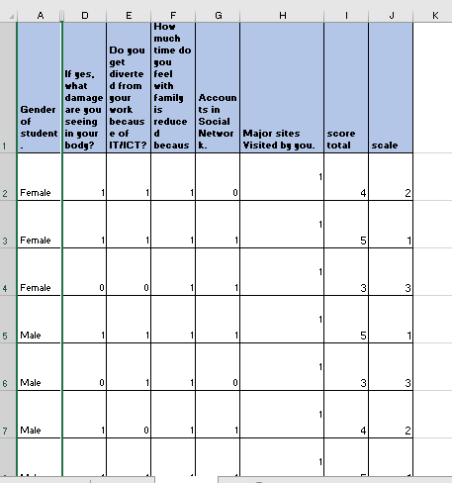

Then we apply the test of association –

*H*0: Gender is independent of variable [E1, E2, E3, E4, E5]  
*H*1: Gender is not independent of variable [E1, E2, E3, E4, E5]

|  |  |  |  |  |
| --- | --- | --- | --- | --- |
| **Crosstab** | | | | |
| Count | | | | |
|  | | Gender of student. | | Total |
| Female | Male |
| scale | execellent | 3 | 9 | 12 |
| very good | 19 | 14 | 33 |
| good | 11 | 21 | 32 |
| bad | 16 | 8 | 24 |
| very bad | 3 | 2 | 5 |
| Total | | 52 | 54 | 106 |

|  |  |  |  |
| --- | --- | --- | --- |
| **Chi-Square Tests** | | | |
|  | Value | df | Asymptotic Significance (2-sided) |
| Pearson Chi-Square | 9.715a | 4 | .046 |
| Likelihood Ratio | 9.960 | 4 | .041 |
| N of Valid Cases | 106 |  |  |
| 1. 2 cells (20.0%) have expected count less than 5. The minimum expected count is 2.45. | | | |

Conclusion:

Since the p-value is less than our chosen significance level α = 0.05, we can reject the null hypothesis, and conclude that Gender is not independent of variable [E1, E2, E3, E4, E5]

We have to see association between General Profile and variable E1, E2, E3, E4, E5

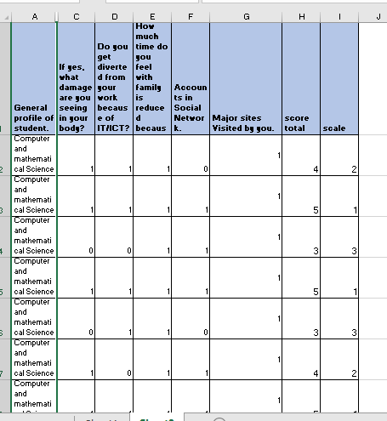

Then we apply the test of association –

*H*0: General Profile is independent of variable [E1, E2, E3, E4, E5]  
*H*1: General Profile is not independent of variable [E1, E2, E3, E4, E5]

|  |  |  |  |  |  |  |
| --- | --- | --- | --- | --- | --- | --- |
| **Crosstab** | | | | | | |
| Count | | | | | | |
|  | | General profile of student. | | | | Total |
| Arts | Commerce | Computer and mathematical Science | Medical science |
| scale | excellent | 0 | 1 | 11 | 0 | 12 |
| very good | 4 | 6 | 20 | 3 | 33 |
| good | 4 | 6 | 21 | 1 | 32 |
| bad | 2 | 7 | 13 | 2 | 24 |
| very bad | 0 | 1 | 2 | 2 | 5 |
| Total | | 10 | 21 | 67 | 8 | 106 |

|  |  |  |  |
| --- | --- | --- | --- |
| **Chi-Square Tests** | | | |
|  | Value | df | Asymptotic Significance (2-sided) |
| Pearson Chi-Square | 15.302a | 12 | .225 |
| Likelihood Ratio | 14.422 | 12 | .275 |
| N of Valid Cases | 106 |  |  |
| a. 14 cells (70.0%) have expected count less than 5. The minimum expected count is .38. | | | |

Conclusion:

General Profile is independent of variable [E1, E2, E3, E4, E5]

Since the p-value is greater than our chosen significance level α = 0.05, we cannot reject the null hypothesis, and conclude that

We have to see association between City and variable E1, E2, E3, E4, E5

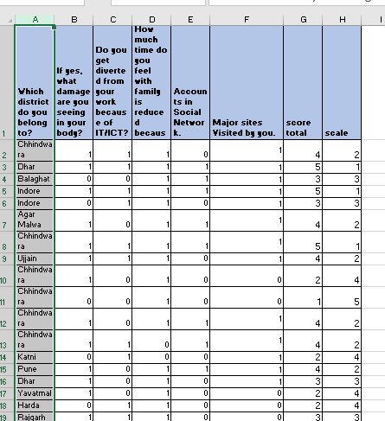

Then we apply the test of association –

*H*0: City is independent of variable [E1, E2, E3, E4, E5]  
*H*1: City is not independent of variable [E1, E2, E3, E4, E5]

|  |  |  |  |
| --- | --- | --- | --- |
| **Chi-Square Tests** | | | |
|  | Value | df | Asymptotic Significance (2-sided) |
| Pearson Chi-Square | 184.029a | 140 | .007 |
| Likelihood Ratio | 156.440 | 140 | .162 |
| N of Valid Cases | 106 |  |  |
| a. 177 cells (98.3%) have expected count less than 5. The minimum expected count is .05. | | | |

Conclusion:

Since the p-value is less than our chosen significance level α = 0.05, we can reject the null hypothesis, and conclude that City is not independent of variable [E1, E2, E3, E4, E5]

Factor Analysis

It is a technique that is used to reduce a large number of variables into fewer numbers of factors.  This technique extracts maximum common variance from all variables and puts them into a common score.  As an index of all variables, we can use this score for further analysis.  Factor analysis is part of [general linear model (GLM)](https://www.statisticssolutions.com/free-resources/directory-of-statistical-analyses/generalized-linear-models/) and this method also assumes several assumptions: there is linear relationship, there is no [multicollinearity](https://www.statisticssolutions.com/multicollinearity/), it includes relevant variables into analysis, and there is true correlation between variables and factors.  Several methods are available, but principal component analysis is used most commonly.

**Steps for Factor analysis**

1. Analyse tab >Dimension Reduction>factor.
2. Drag all the items in the variables section to form factors.
3. In descriptive check box for univariate descriptive and initial solution, KMO and Bartlett’s test and click continue.
4. In Extraction tab select correlation matrix to be displayed, unrotated factor solution and scree plot to form factors
5. In Rotation tab select varimax and rotated solution and click continue.
6. In Scores tab select save as variable and click continue.

1. In factor Analysis option supress small coefficients i.e., all the coefficient below 0.5.
2. Click ok in Factor analysis tab.

**OUTPUT OF FACTOR ANALYSIS**

|  |  |  |
| --- | --- | --- |
| **KMO and Bartlett's Test** | | |
| Kaiser-Meyer-Olkin Measure of Sampling Adequacy. | | .780 |
| Bartlett's Test of Sphericity | Approx. Chi-Square | 180.744 |
| df | 78 |
| Sig. | .000 |

KMO measure of sampling adequacy is a test to assess the appropriateness of using factor analysis on the data set.

Since KMO= 0.78>0.6

Bartlett’s test of sphericity is used test the null hypothesis that the variables in the population correlation matrix are uncorrelated.

Since p value is less than 0.05. So, there is significant difference and we fail to accept null hypothesis, hence concluding variables are correlated.

Thus, the data is good fit for factor analysis

|  |  |  |
| --- | --- | --- |
| **Communalities** | | |
|  | Initial | Extraction |
| Q1 | 1.000 | .531 |
| Q2 | 1.000 | .648 |
| Q3 | 1.000 | .511 |
| Q4 | 1.000 | .562 |
| Q5 | 1.000 | .687 |
| Q6 | 1.000 | .742 |
| Q7 | 1.000 | .604 |
| Q8 | 1.000 | .666 |
| Q9 | 1.000 | .612 |
| Q10 | 1.000 | .700 |
| Q11 | 1.000 | .566 |
| Q12 | 1.000 | .660 |
| Q13 | 1.000 | .444 |
| Extraction Method: Principal Component Analysis. | | |

[Communality in factor analysis is a **measure of how much of the variance of a variable is explained by the common factors**](https://www.bing.com/ck/a?!&&p=395b22ba4a13e6a2JmltdHM9MTcwMzExNjgwMCZpZ3VpZD0xOTAyYzZlYi0wMjZhLTZhNGYtMjdjOC1kNTI1MDM2YzZiYWQmaW5zaWQ9NTc1NA&ptn=3&ver=2&hsh=3&fclid=1902c6eb-026a-6a4f-27c8-d525036c6bad&psq=communalities+in+factor+analysis&u=a1aHR0cHM6Ly9jaGVtcGVkaWEuaW5mby9pbmZvL2ZhY3Rvcl9hbmFseXNpc19jb21tdW5hbGl0eS8&ntb=1). [It is calculated by the correlations between the variable and the factors](https://www.bing.com/ck/a?!&&p=1687f970a7ef8cb4JmltdHM9MTcwMzExNjgwMCZpZ3VpZD0xOTAyYzZlYi0wMjZhLTZhNGYtMjdjOC1kNTI1MDM2YzZiYWQmaW5zaWQ9NTc1OA&ptn=3&ver=2&hsh=3&fclid=1902c6eb-026a-6a4f-27c8-d525036c6bad&psq=communalities+in+factor+analysis&u=a1aHR0cHM6Ly93d3cuc3RhdGlzdGljc2hvd3RvLmNvbS9jb21tdW5hbGl0eS8&ntb=1). [High communality means that the variable is well represented by the factor solution, while low communality means that the variable has a lot of specific or random variance](https://www.bing.com/ck/a?!&&p=1af3ca4068802bdcJmltdHM9MTcwMzExNjgwMCZpZ3VpZD0xOTAyYzZlYi0wMjZhLTZhNGYtMjdjOC1kNTI1MDM2YzZiYWQmaW5zaWQ9NTc2MA&ptn=3&ver=2&hsh=3&fclid=1902c6eb-026a-6a4f-27c8-d525036c6bad&psq=communalities+in+factor+analysis&u=a1aHR0cHM6Ly9jaGVtcGVkaWEuaW5mby9pbmZvL2ZhY3Rvcl9hbmFseXNpc19jb21tdW5hbGl0eS8&ntb=1). [Communality is usually denoted by h2](https://www.bing.com/ck/a?!&&p=f5454c184ded9a68JmltdHM9MTcwMzExNjgwMCZpZ3VpZD0xOTAyYzZlYi0wMjZhLTZhNGYtMjdjOC1kNTI1MDM2YzZiYWQmaW5zaWQ9NTc2Mg&ptn=3&ver=2&hsh=3&fclid=1902c6eb-026a-6a4f-27c8-d525036c6bad&psq=communalities+in+factor+analysis&u=a1aHR0cHM6Ly93d3cuc3RhdGlzdGljc2hvd3RvLmNvbS9jb21tdW5hbGl0eS8&ntb=1).

|  |  |  |  |  |  |  |  |  |  |  |
| --- | --- | --- | --- | --- | --- | --- | --- | --- | --- | --- |
| **Total Variance Explained** | | | | | | | | | | |
| Component | Initial Eigenvalues | | | Extraction Sums of Squared Loadings | | | Rotation Sums of Squared Loadings | | | |
| Total | % of Variance | Cumulative % | Total | % of Variance | Cumulative % | Total | % of Variance | Cumulative % |
| 1 | 2.403 | 18.487 | 18.487 | 2.403 | 18.487 | 18.487 | 1.781 | 13.700 | 13.700 |
| 2 | 1.704 | 13.110 | 31.597 | 1.704 | 13.110 | 31.597 | 1.773 | 13.641 | 27.341 |
| 3 | 1.410 | 10.847 | 42.444 | 1.410 | 10.847 | 42.444 | 1.537 | 11.820 | 39.161 |
| 4 | 1.122 | 8.632 | 51.076 | 1.122 | 8.632 | 51.076 | 1.472 | 11.324 | 50.485 |
| 5 | 1.094 | 8.417 | 59.493 | 1.094 | 8.417 | 59.493 | 1.171 | 9.008 | 59.493 |
| 6 | .969 | 7.455 | 66.948 |  |  |  |  |  |  |
| 7 | .881 | 6.776 | 73.724 |  |  |  |  |  |  |
| 8 | .786 | 6.046 | 79.770 |  |  |  |  |  |  |
| 9 | .736 | 5.660 | 85.430 |  |  |  |  |  |  |
| 10 | .590 | 4.538 | 89.968 |  |  |  |  |  |  |
| 11 | .520 | 4.001 | 93.969 |  |  |  |  |  |  |
| 12 | .430 | 3.306 | 97.275 |  |  |  |  |  |  |
| 13 | .354 | 2.725 | 100.000 |  |  |  |  |  |  |
| Extraction Method: Principal Component Analysis. | | | | | | | | | | |

Total variance explained by 5 factors is 59.493

[Total variance in factor analysis is the **amount of variation in the original variables that can be explained by the factors**](https://www.bing.com/ck/a?!&&p=59b5824caf1cf073JmltdHM9MTcwMzExNjgwMCZpZ3VpZD0xOTAyYzZlYi0wMjZhLTZhNGYtMjdjOC1kNTI1MDM2YzZiYWQmaW5zaWQ9NTczOA&ptn=3&ver=2&hsh=3&fclid=1902c6eb-026a-6a4f-27c8-d525036c6bad&psq=total+variance+explained+in+factor+analysis&u=a1aHR0cHM6Ly9tYXRoLnVubS5lZHUvfmphbWVzL3cxNC1TVEFUNTc2Yy5wZGY&ntb=1)[**1**](https://www.bing.com/ck/a?!&&p=bd686d3f893f42f2JmltdHM9MTcwMzExNjgwMCZpZ3VpZD0xOTAyYzZlYi0wMjZhLTZhNGYtMjdjOC1kNTI1MDM2YzZiYWQmaW5zaWQ9NTczOQ&ptn=3&ver=2&hsh=3&fclid=1902c6eb-026a-6a4f-27c8-d525036c6bad&psq=total+variance+explained+in+factor+analysis&u=a1aHR0cHM6Ly9tYXRoLnVubS5lZHUvfmphbWVzL3cxNC1TVEFUNTc2Yy5wZGY&ntb=1). [The sum of all eigenvalues, which are the squared factor loadings, equals the total number of variables](https://www.bing.com/ck/a?!&&p=5eff0cb0e9d2d593JmltdHM9MTcwMzExNjgwMCZpZ3VpZD0xOTAyYzZlYi0wMjZhLTZhNGYtMjdjOC1kNTI1MDM2YzZiYWQmaW5zaWQ9NTc0MA&ptn=3&ver=2&hsh=3&fclid=1902c6eb-026a-6a4f-27c8-d525036c6bad&psq=total+variance+explained+in+factor+analysis&u=a1aHR0cHM6Ly93d3cucHJpbmNldG9uLmVkdS9-b3RvcnJlcy9TdGF0YS9GYWN0b3I&ntb=1)

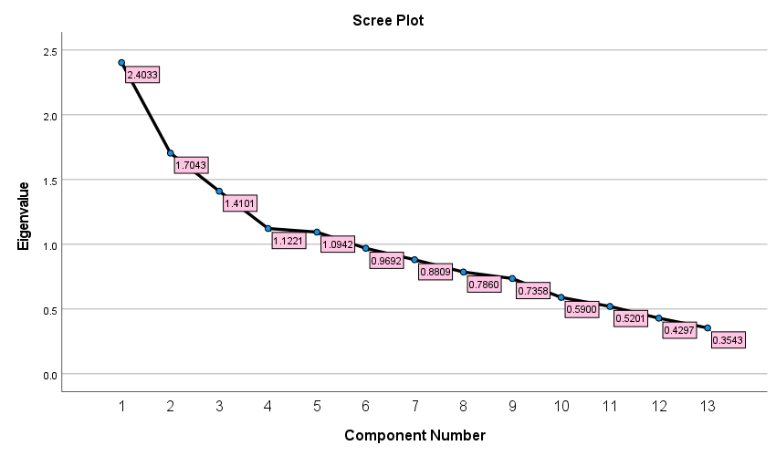

5 Factors having Eigen value less than 1

A scree plot is**a line plot of the eigenvalues of factors or principal components in an analysis.** The scree plot is used to determine the number of factors to retain in an exploratory factor analysis (FA) or principal components to keep in a principal component analysis (PCA)

|  |  |  |  |  |  |
| --- | --- | --- | --- | --- | --- |
| **Component Matrix** | | | | | |
|  | Component | | | | |
| 1 | 2 | 3 | 4 | 5 |
| Q1 |  |  |  |  |  |
| Q2 |  | -.570 |  |  |  |
| Q3 |  |  |  |  |  |
| Q4 |  |  | .564 |  |  |
| Q5 |  | .534 |  |  |  |
| Q6 |  | .585 |  |  | .523 |
| Q7 | .563 |  |  |  |  |
| Q8 | .678 |  |  |  |  |
| Q9 |  | .514 |  |  |  |
| Q10 | .693 |  |  |  |  |
| Q11 |  |  |  |  |  |
| Q12 |  |  |  | -.616 |  |
| Q13 |  |  |  |  |  |
| Extraction Method: Principal Component Analysis. | | | | | |
| 1. 5 components extracted. | | | | | |

|  |  |  |  |  |  |
| --- | --- | --- | --- | --- | --- |
| **Rotated Component Matrix** | | | | | |
|  | Component | | | | |
| 1 | 2 | 3 | 4 | 5 |
| Q1 |  |  | .624 |  |  |
| Q2 |  | .773 |  |  |  |
| Q3 | .696 |  |  |  |  |
| Q4 | .573 |  |  |  |  |
| Q5 | .716 |  |  |  |  |
| Q6 |  |  |  | .819 |  |
| Q7 |  | .740 |  |  |  |
| Q8 |  |  |  |  |  |
| Q9 |  |  |  | .707 |  |
| Q10 |  |  |  |  |  |
| Q11 |  |  | .664 |  |  |
| Q12 |  |  |  |  | .791 |
| Q13 |  |  |  |  |  |
| Extraction Method: Principal Component Analysis.  Rotation Method: Varimax with Kaiser Normalization. | | | | | |
| a. Rotation converged in 6 iterations. | | | | | |

After removing all the loadings less than 0.5 and concluding from the above matrix that there is total 5 factor and no. of items loadings in each factor are as follows:

Factor 1: Item (3,4,5)

Factor 2: Item (2,7)

Factor 3: Item (1,11)

Factor 4: Item (6,9)

Factor 5: Item (12)

|  |  |  |  |  |  |
| --- | --- | --- | --- | --- | --- |
| **Component Transformation Matrix** | | | | | |
| Component | 1 | 2 | 3 | 4 | 5 |
| 1 | -.615 | .555 | .442 | .305 | .159 |
| 2 | .095 | -.587 | .466 | .644 | -.116 |
| 3 | .767 | .442 | .409 | .034 | .219 |
| 4 | .121 | .366 | -.191 | .300 | -.851 |
| 5 | .102 | .133 | -.619 | .633 | .434 |
| Extraction Method: Principal Component Analysis.  Rotation Method: Varimax with Kaiser Normalization.  After exploring these 5 factors and going through correlation matrix for these 5 factors now it’s time to perform CFA | | | | | |

To check construct reliability

What is reliability?

* The consistency of your measurement instrument.
* The degree to which an instrument measure the same way each time it is used under same condition with the same subject

We have 3 items in first component so we check reliability for these 3 factors by applying **Cronbach’s Alpha.**

Steps to apply Cronbach’s Alpha in SPSS:

1. Go to Analyse tab click search for scale.
2. In scale go for Reliability Analysis.
3. A dialogue box will appear, select items to be test.
4. Click ok to get the value of Cronbach’s Alpha.

|  |  |  |  |
| --- | --- | --- | --- |
| **Case Processing Summary** | | | |
|  | | | |
|  | | N | % |
| Cases | Valid | 106 | 100.0 |
| Excludeda | 0 | .0 |
| Total | 106 | 100.0 |
| a. Listwise deletion based on all variables in the procedure. | | | |
| |  |  | | --- | --- | | **Reliability Statistics** | | | Cronbach's Alpha | N of Items | | .749 | 3 |   Since the value of Cronbach Alpha for these 3 items (Q3, Q4, Q5) is greater than 0.7  CR>0.7 is accepted  So, we can conclude that these items are reliable.  **Meaningful naming of constructs**   1. Factor 1 – effect of ITC   Q3, Q4, Q5     1. Factor 2 – Usage and skill developed   Q2, Q7   1. Factor 3- ICT usage and Education   Q1, Q11   1. Factor 4- Family time reduced   Q6, Q9   1. Factor 5- ICT Based Education   Q12  **Conclusion**    For chi- square-  Chi – square test the chi-square test is statistical tool used to check if two categorical variables are related or independent  The variables [E1, E2, E3, E4, E5] i.e.,  **E1 =** If yes, what damage are you seeing in your body?  **1= “Eye damage”, 0 = “not eye damage”**  **E2 =** Do you get diverted from your work because of IT/ICT?  **1 = “yes”, 0 = “no”**  **E3** = do you feel time with family is reduced because of over usage of IT/ICT?  **1 = “yes”, 0 = “no”**  **E4 =** Accounts in Social Network.  **1 = “Instagram, Facebook, linked In”, 0 = “not”**  **E5 =** Major sites Visited by you.   * 1. **= “YouTube”, 0 = “not YouTube”**  1. The Age group is independent of variable [E1, E2, E3, E4, E5] 2. The Gender is dependent of variable [E1, E2, E3, E4, E5] 3. The General Profile is independent of variable [E1, E2, E3, E4, E5] 4. The City Student belong is dependent of variable [E1, E2, E3, E4, E5]     For Factor analysis-  The overall objective of factor analysis is data summarization and data reduction. We applied factor analysis and the reduce factors are-   1. Factor 1 – effect of ITC   Q3, Q4, Q5     1. Factor 2 – Usage and skill developed   Q2, Q7   1. Factor 3- ICT usage and Education   Q1, Q11   1. Factor 4- Family time reduced   Q6, Q9   1. Factor 5- ICT Based Education   Q12  Then After exploring these 5 factors now, we apply test for reliability  Test of reliability-  We applied test of reliability for factor 1 which has items (Q3, Q4, Q5) and they accept the Cronbach Alpha test so we can say the Factor is reliable.  **Limitation-**  Though ICT has great Impact on Education System and improvement on Communication and Knowledge there is huge down side of ICT towards Health and detaching from family.  **Reference-**   * [**https://www.google.com/webhp?hl=en&sa=X&ved=0ahUKEwiH2umf76KDAxXUTWwGHU-aCRcQPAgJ**](https://www.google.com/webhp?hl=en&sa=X&ved=0ahUKEwiH2umf76KDAxXUTWwGHU-aCRcQPAgJ) * [**https://libguides.library.kent.edu/spss/chisquare**](https://libguides.library.kent.edu/spss/chisquare) * [**https://www.simplilearn.com/tutorials/statistics-tutorial/chi-square-test**](https://www.simplilearn.com/tutorials/statistics-tutorial/chi-square-test) * [**https://www.qualtrics.com/au/experience-management/research/factor-analysis/#:~:text=Factor%20analysis%20is%20a%20way,Principal%20Component%20Analysis%20(PCA).**](https://www.qualtrics.com/au/experience-management/research/factor-analysis/#:~:text=Factor%20analysis%20is%20a%20way,Principal%20Component%20Analysis%20(PCA).) * [**https://www.spss-tutorials.com/spss-factor-analysis-tutorial/**](https://www.spss-tutorials.com/spss-factor-analysis-tutorial/) * [**https://www.ibm.com/docs/en/spss-statistics/25.0.0?topic=features-reliability-analysis**](https://www.ibm.com/docs/en/spss-statistics/25.0.0?topic=features-reliability-analysis) * [**https://www.statisticssolutions.com/free-resources/directory-of-statistical-analyses/reliability-analysis/#:~:text=The%20analysis%20on%20reliability%20is,different%20administrations%20of%20the%20scale.**](https://www.statisticssolutions.com/free-resources/directory-of-statistical-analyses/reliability-analysis/#:~:text=The%20analysis%20on%20reliability%20is,different%20administrations%20of%20the%20scale.)   **Books Referred-** [FUNDAMENTALS OF MATHEMATICAL STATISTICS](https://www.dcpehvpm.org/E-Content/Stat/FUNDAMENTAL%20OF%20MATHEMATICAL%20STATISTICS-S%20C%20GUPTA%20&%20V%20K%20KAPOOR.pdf)FUNDAMENTALS OF APPLIED MATHEMATICAL STATISTICS | | | |